WEEK 06-01

PRACTICE SESSION CODING

Name: SRI RAMKANNA M

Roll No: 241801275

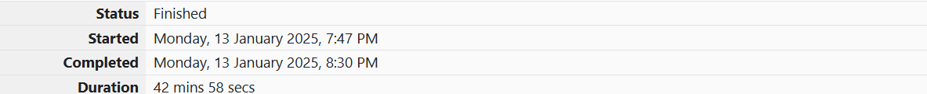

1.PROBLEM STATEMENT:

Given an array A of sorted integers and another non negative integer k, find if there exists 2 indices i and j such that A[i] - A[j] = k, i != j. Input Format 1. First line is number of test cases T. Following T lines contain: 2. N, followed by N integers of the array 3. The non-negative integer k Output format Print 1 if such a pair exists and 0 if it doesn’t. Sample Input: 1 3 1 3 5 4 Sample Output: 1

PROGRAM CODING:

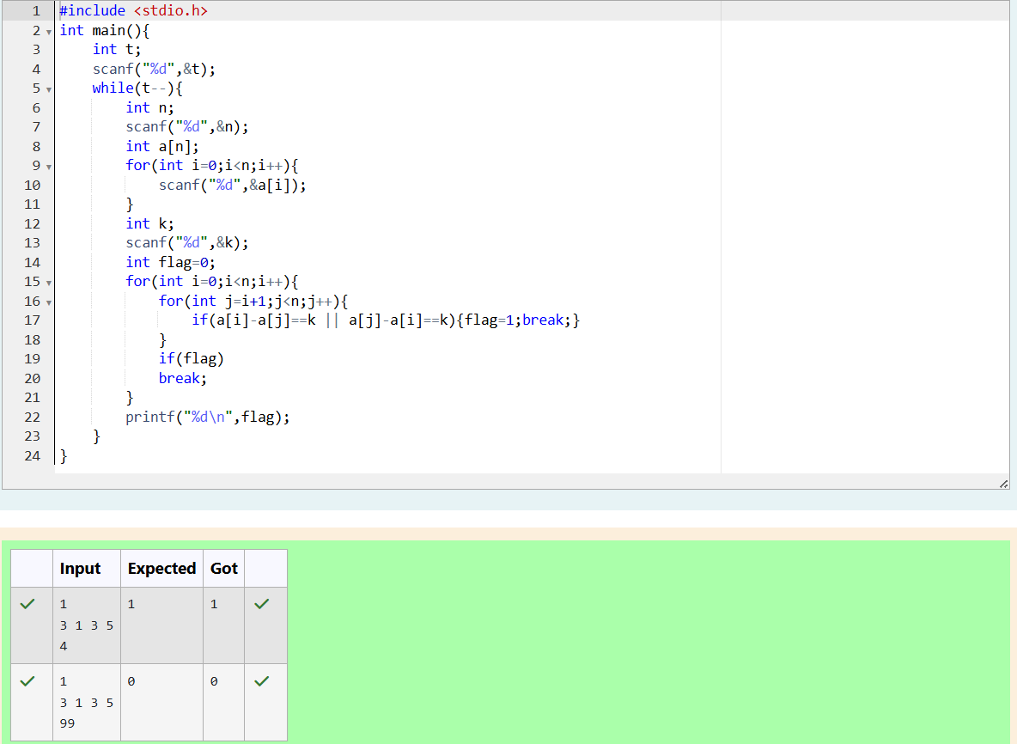

1.PROBLEM STATEMENT:

Given an array A of sorted integers and another non negative integer k, find if there exists 2 indices i and j such that A[i] - A[j] = k, i != j. Input Format 1. First line is number of test cases T. Following T lines contain: 2. N, followed by N integers of the array 3. The non-negative integer k Output format Print 1 if such a pair exists and 0 if it doesn’t. Sample Input: 1 3 1 3 5 4 Sample Output: 1

PROGRAM CODING:

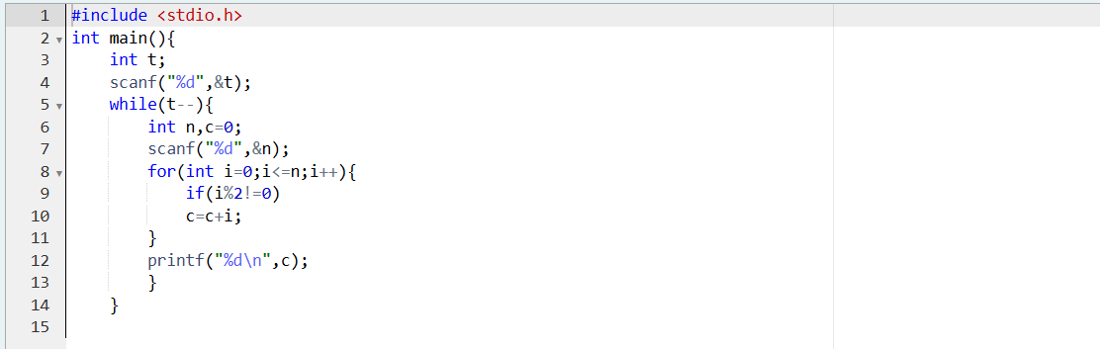

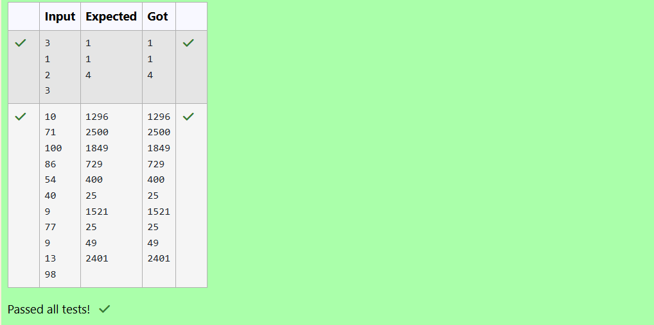

3. PROBLEM STATEMENT:

The number of goals achieved by two football teams in matches in a league is given in the form of two lists. Consider: • Football team A, has played three matches, and has scored { 1 , 2 , 3 } goals in each match respectively. • Football team B, has played two matches, and has scored { 2, 4 } goals in each match respectively. • Your task is to compute, for each match of team B, the

total number of matches of team A, • where team A has scored less than or equal to the number of goals scored by team B in that match. In the above case: • For 2 goals scored by team B in its first match, team A has 2 matches with scores 1 and 2. • For 4 goals scored by team B in its second match, team A has 3 matches with scores 1, 2 and 3. Hence, the answer: {2, 3}. Complete the code in the editor below. The program must return an array of m positive integers, one for each maxes[i] representing the total number of elements nums[j] satisfying nums[j] ≤ maxes[i] where 0 ≤ j < n and 0 ≤ i < m, in the given order. It has the following: nums[nums[0],...nums[n-1]]: first array of positive integers maxes[maxes[0],...maxes[n-1]]: second array of positive integers Constraints: 2 ≤ n, m ≤ 105, 1 ≤ nums[j] ≤ 109, where 0 ≤ j < n, 1 ≤ maxes[i] ≤ 109, where 0 ≤ i < m. Input Format For Custom Testing Input from stdin will be processed as follows and passed to the function. The first line contains an integer n, the number of elements in nums. The next n lines each contain an integer describing nums[j] where 0 ≤ j < n. The next line contains an integer m, the number of elements in maxes. The next m lines each contain an integer describing maxes[i] where 0 ≤ i < m. Sample Input 4 1 4 2 4 2 3 5 Sample Output 2 4

PROGRAM CODING:

